**DAILY ONLINE ACTIVITIES SUMMARY**

|  |  |  |  |  |  |
| --- | --- | --- | --- | --- | --- |
| **Date:** | **29-05-2020** | | **Name:** | **Shah Dhruvil Amit** | |
| **Sem & Sec** | **6th - B** | | **USN:** | **4AL17CS083** | |
| **Online Test Summary** | | | | | |
| **Subject** | **OPERATION RESEARCH** | | | | |
| **Max. Marks** | **30** | **Score** | | **30** | |
| **Certification Course Summary** | | | | | |
| **Course** | **Build an e-commerce with ReactJS** | | | | |
| **Certificate Provider** | **learncodeonline** | **Duration** | | | **As per progress(no duration specified)** |
| **Coding Challenges** | | | | | |
|  | | | | | |
| **Status: executed** | | | | | |
| **Uploaded the report in GitHub** | | **Yes** | | | |
| **If yes Repository name** | | <https://github.com/DhruvilShah99/Daily-Updates> | | | |
| **Uploaded the report in slack** | | **Yes** | | | |

Online Test Details:

Second I A of OR

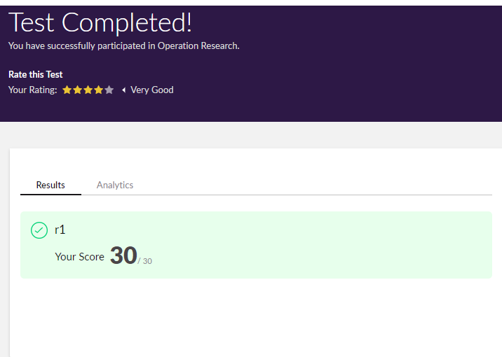

Certification Course Details:

Report

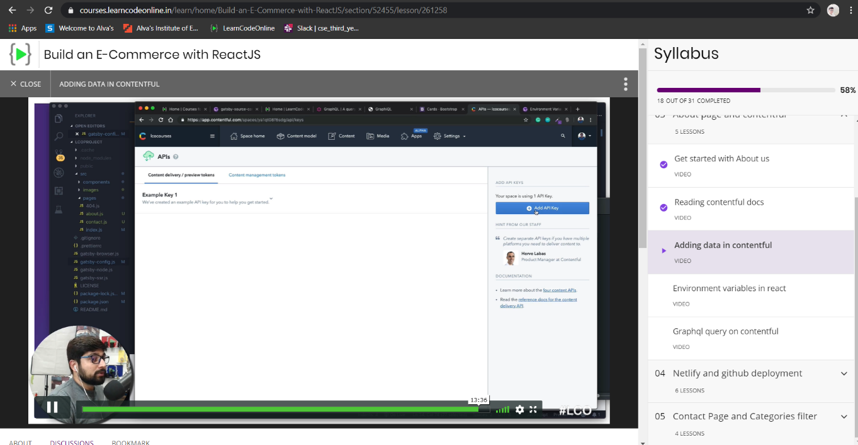

In today’s session of online certification, I have added some data in contentful site regarding the courses to be displayed in the site.

Webinar: 12:00 PM TO 1:30 PM

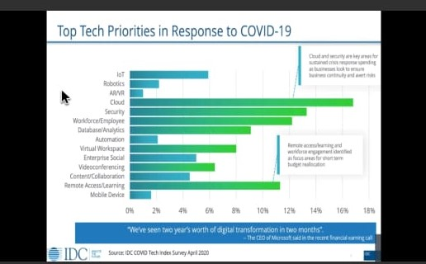

Coding Challenges Details:

The below GitHub link for details

<https://github.com/DhruvilShah99/Daily-Updates>

P-1

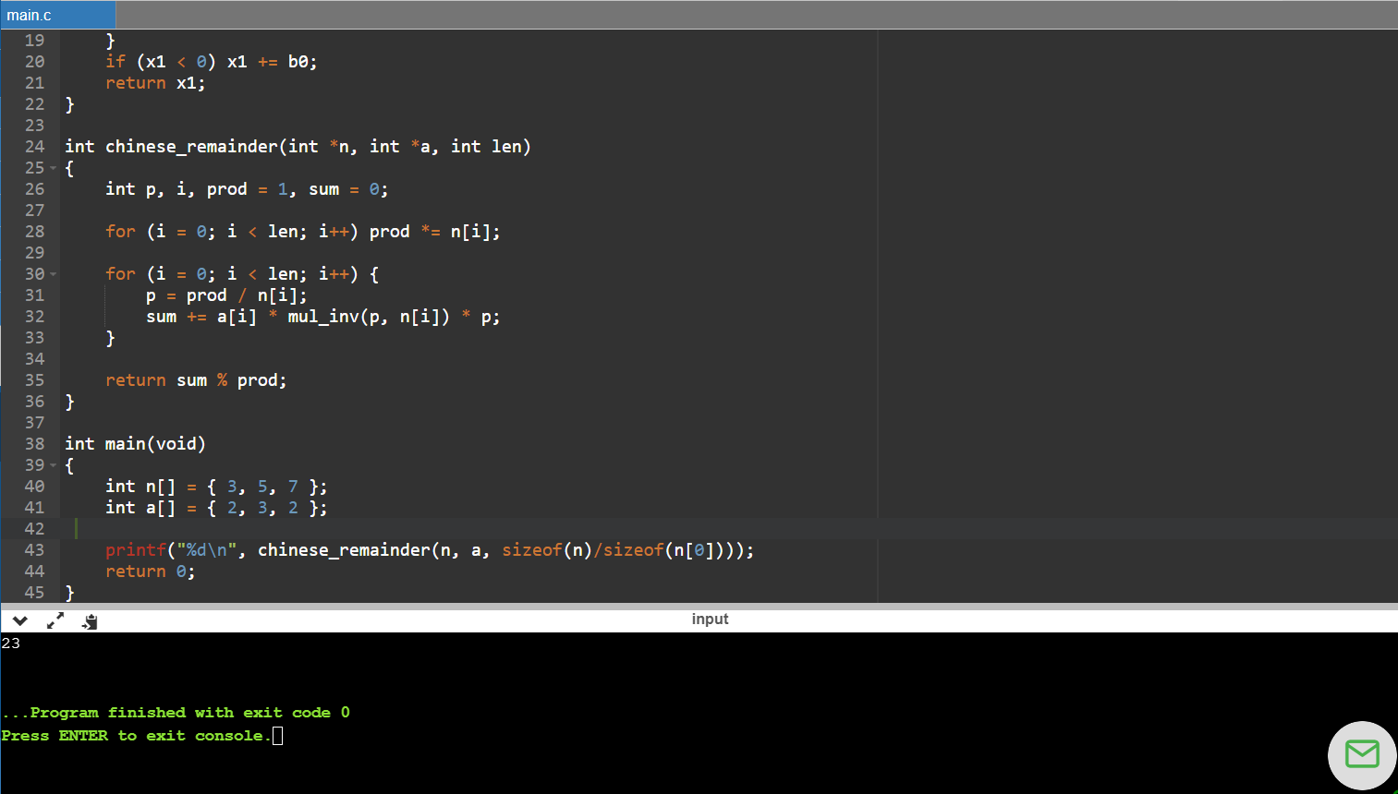

This program implemented in order to get the direct values using Chinese remainder theorem in C.

P-2

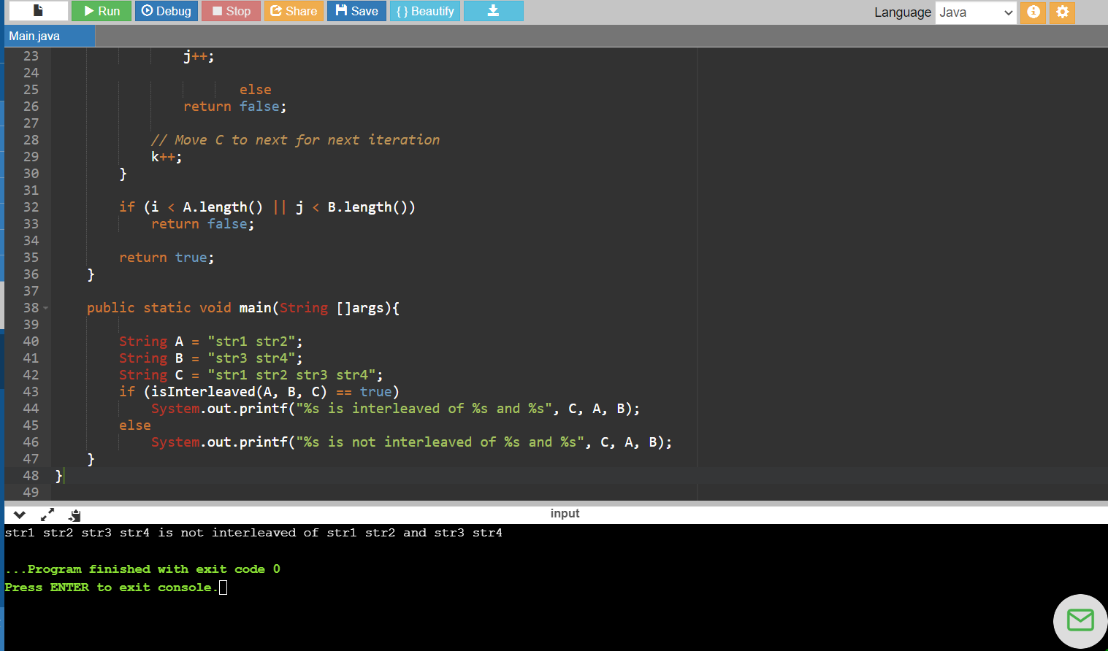

**This java program shows the string interleaved or not.**

**P-3**

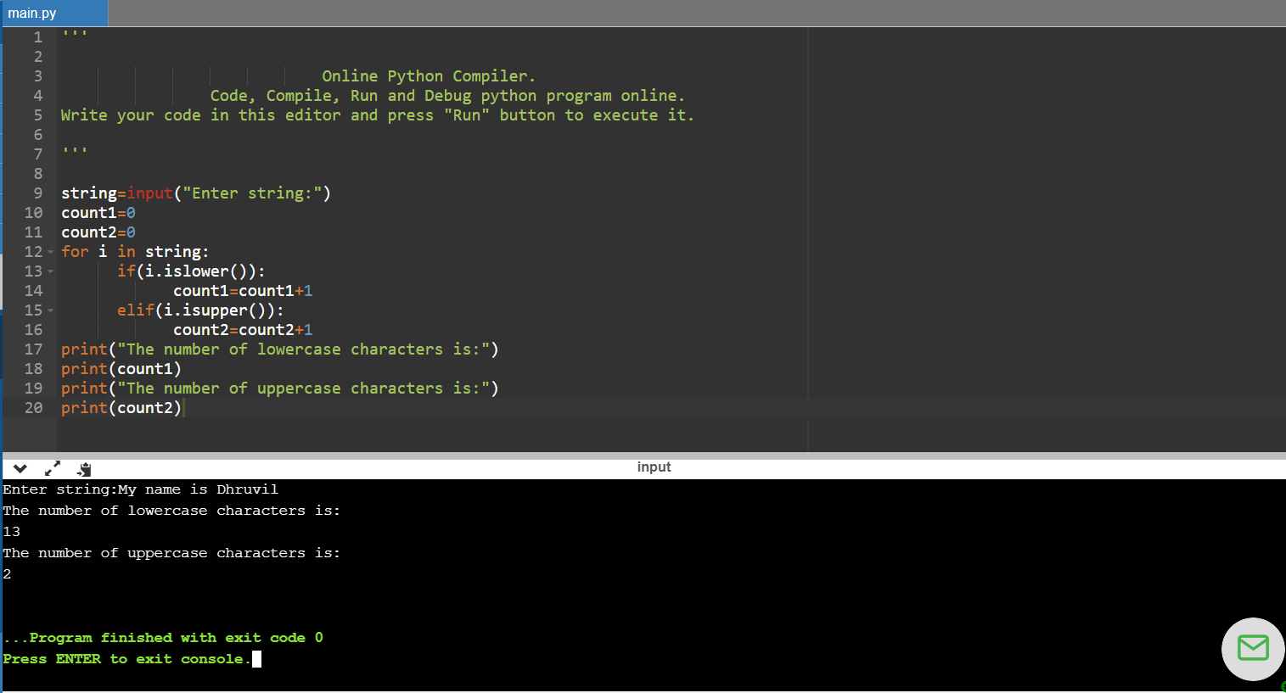

**This python program takes the input from user and calculate total number of lowercases and uppercases in the string.**